Burgess Hill Cricket Club

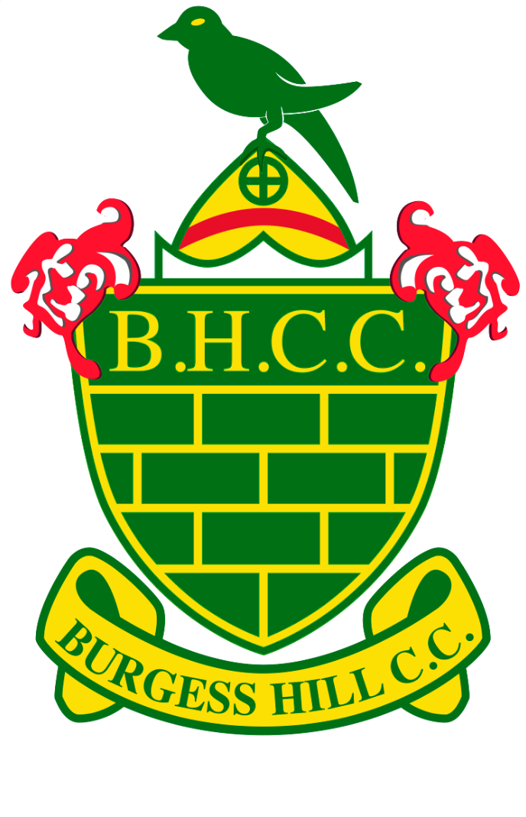
Membership Application Form 2018

Burgess Hill Cricket Club is a community amateur sports club affiliated to the Sussex Cricket Board and the ECB, a SCCC Board Focus Club and Clubmark accredited. Clubmark provides a UKCC ECB accreditation, assuring parents and guardians that qualified and certified coaches and volunteers care for their children.
Adult Membership (Men), Student Membership – over 16 (Men) - £60.00
Ladies, Student Membership – over 16 (Girls) - £30
Please complete the form below and send a scanned copy by email to Matt Charman or Kevin Hale. Payment can be made online to the following BHCC account – please use the surname of the member you are paying for as reference and email mattcharman76@googlemail.com and kevinhale72@yahoo.co.uk to advise when paid so monies can be reconciled. Please include all relevant information for our records below copy. Cheques should be made payable to Burgess Hill CC
HSBC Sort Code: 40-15-16 Account Number : 31398172

Junior Membership: Boys £60.00, Girls £30.00 (Applicable to all year 11 or under playing youth cricket)
(for 2+ boys from one family, membership will be £60 for 1st, then £35.00 for 2nd/3rd etc, so two boys, membership total £95.00. Girl’s membership will be £30 for each child.)
Membership forms can be emailed and payment made online to the same BHCC account (please note we are now using the same account for all payments) – please use the surname and initial of the member you are paying for as reference and email ursulapummell@aol.co.uk and kevinhale72@yahoo.co.uk to advise when paid so money can be reconciled. Please include all relevant information for our records below. Forms can also be returned to Ursula Pummell (Membership Secretary) 80 Fairfield Road, Burgess Hill, RH15 8NT. Cheques should be made payable to Burgess Hill CC.

HSBC Sort Code: 40-15-16 Account Number: 31398172

If you are 16 or under please ensure your parent or guardian signs this form before it is returned. By signing this form you agree to comply with all the club’s policies and procedures, copies of which are posted on the club’s website and notice boards.
Name | Date of Birth | Gender
 |  | ◻ Male ◻ Female
Home Address | Postcode | Email Address (please print clearly)
 | Home telephone no. | Mobile Number
Applicants Signature | Date | Membership type (Adult/Junior)
Signature of Parent/Carer | Date | Parent/Carer email address
Relevant medical details BHCC should know re applicant

